This file shows progress and develop of the first house

Gothic style house

“The Fall of the House of Usher” like escape haunt

Mansion, Castle,

Fantasty like? Realistic?

Inspiration?

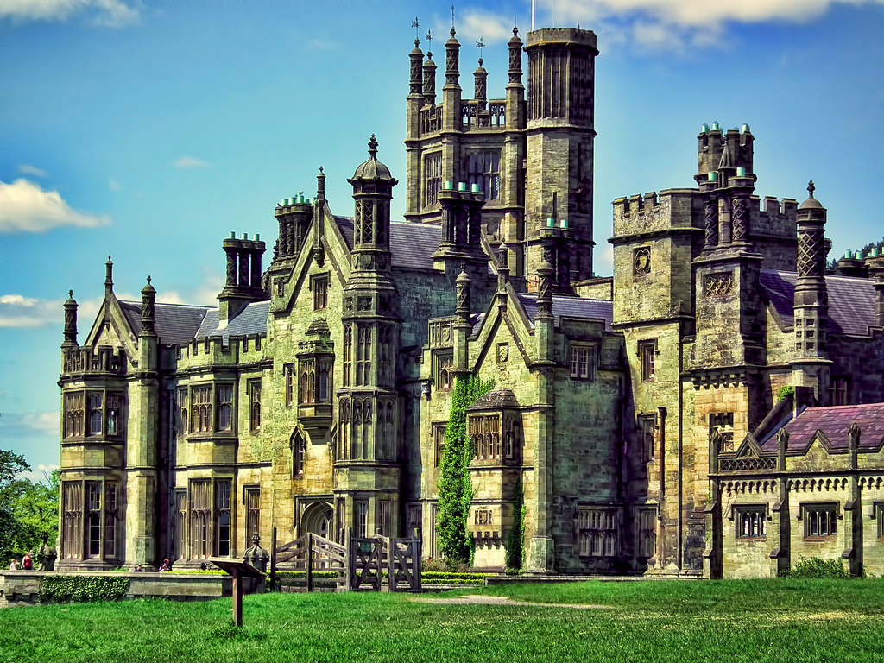

Steve Richards  
Gothic Mansion

Margam, Wales, United Kingdom

<https://www.flickr.com/photos/top-shot-man/7190814716>

Margam Castle

Entrance Hall

Fence idea:  
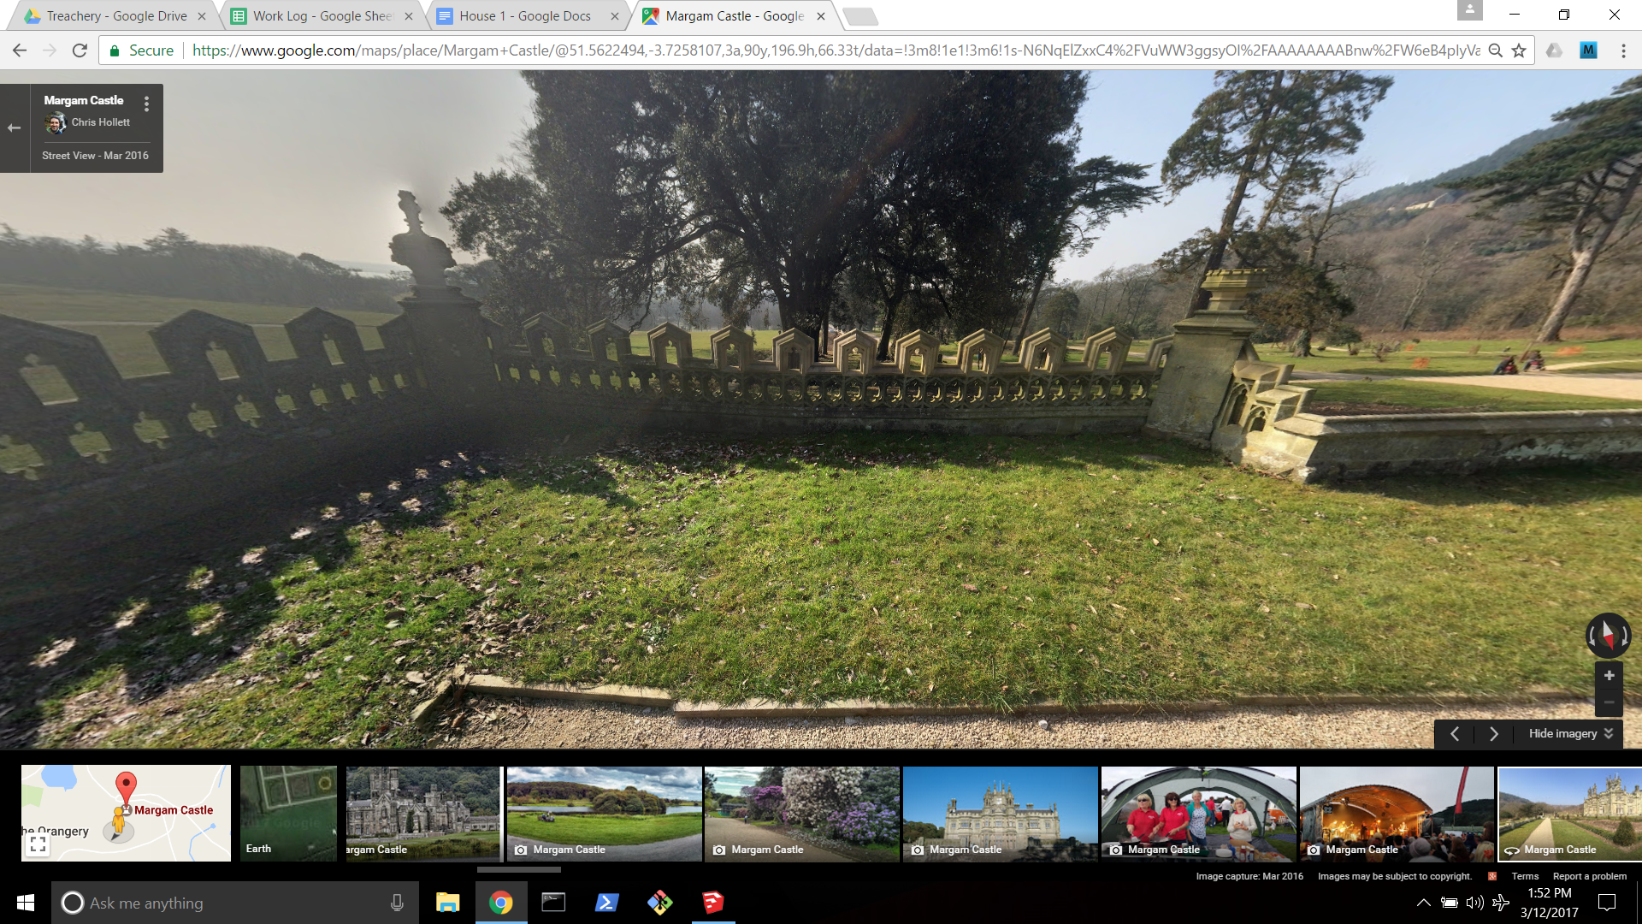

Progress on making First House

3-12-17 Morning  
Picture of house from front

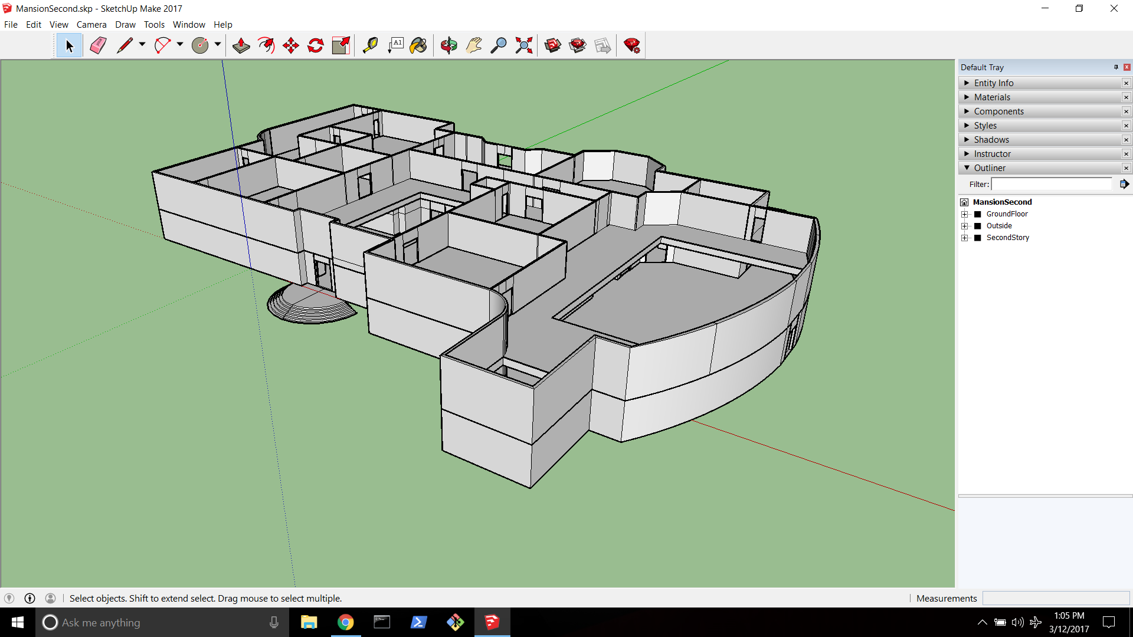

Picture of house from back

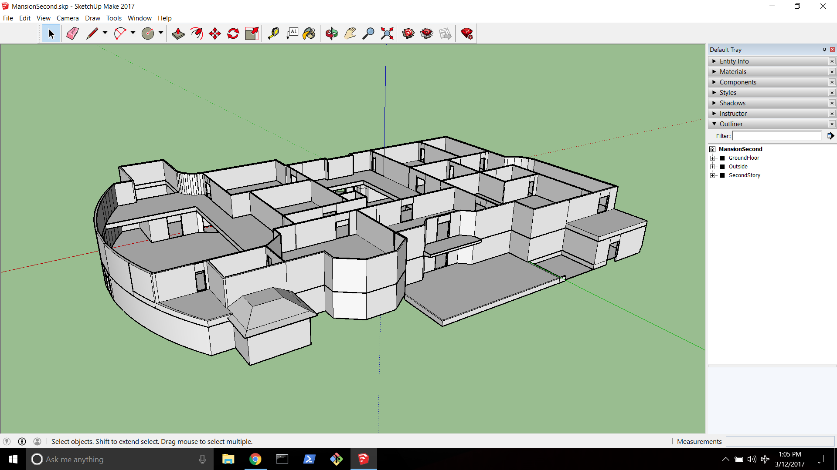

Picture of first story

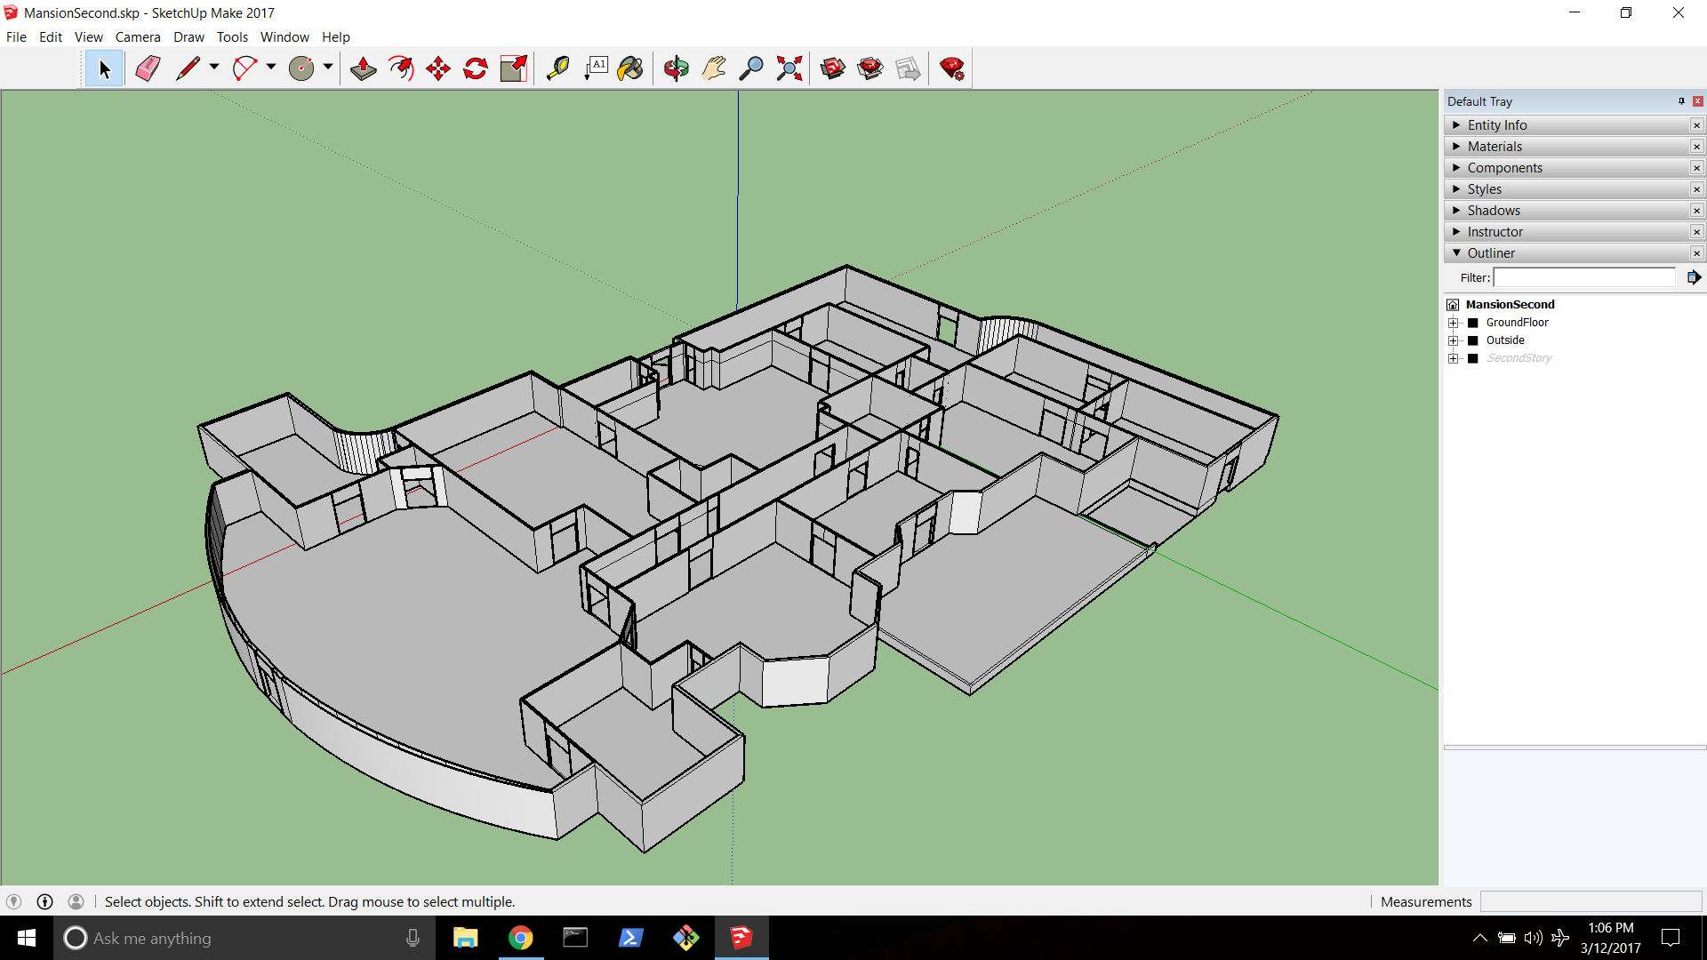

Objectives for 3-13-17:

* Add outside
* Add Basement
* Add Roof

Future Objectives

* Add textures
* Add windows
* Get list of rooms and items to add
* Add details

Daily Progress

1:00PM Started

Working on outside

2:48PM - added church

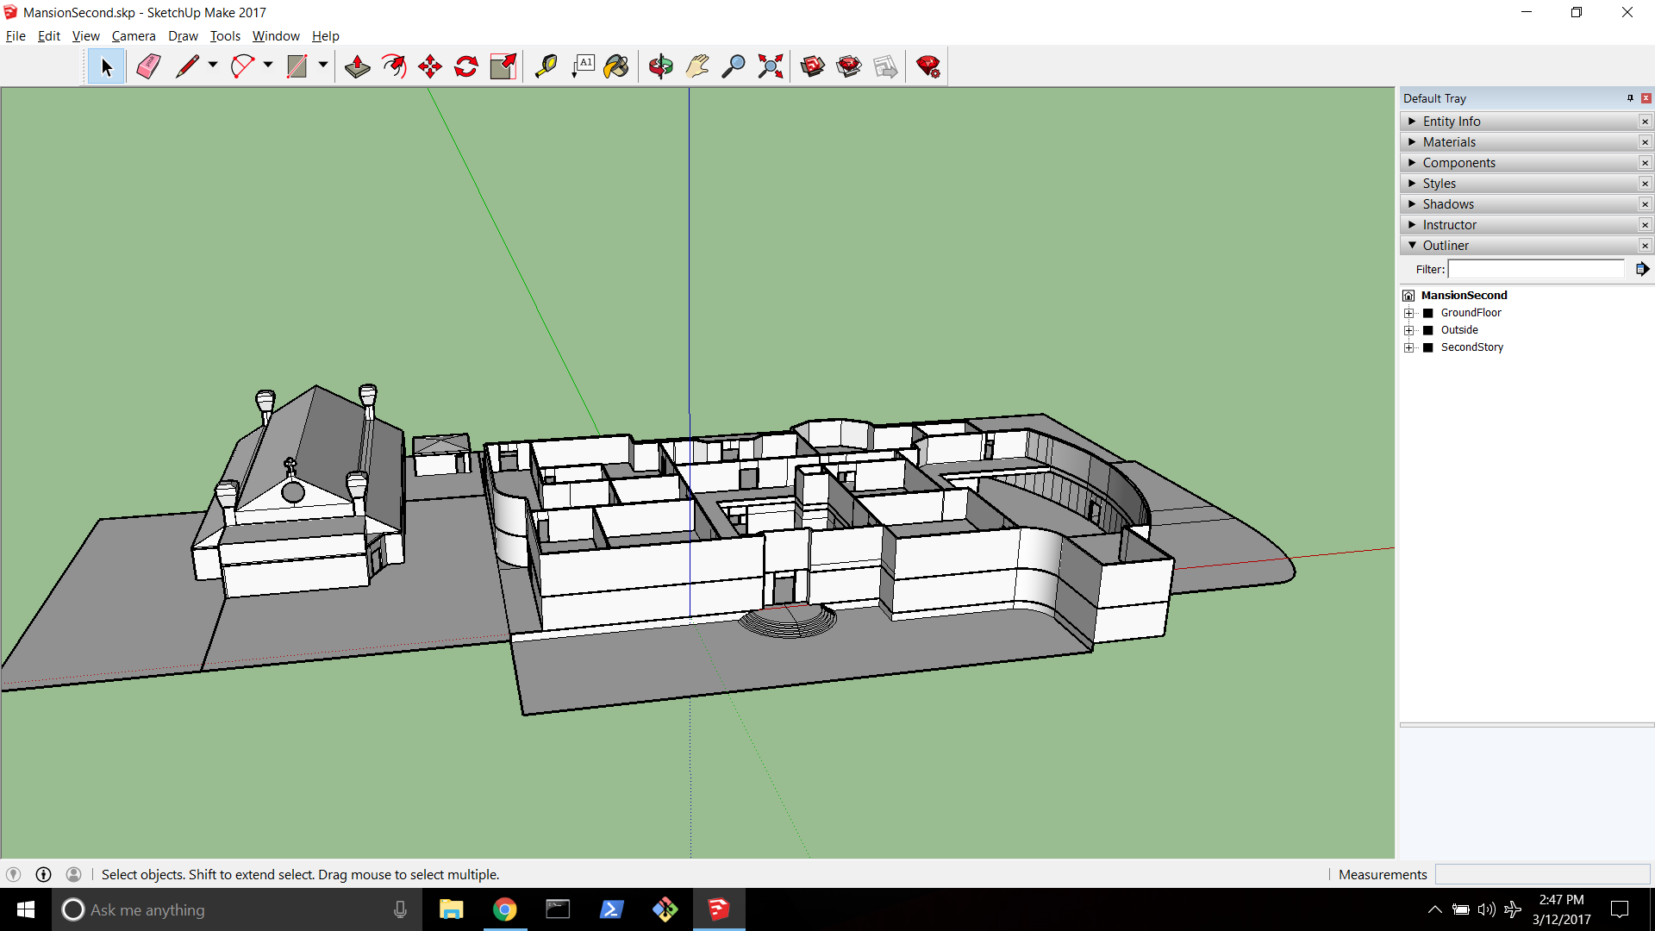

2:50PM - Started on Roof

3-13-17

1:54AM - Stopped work on Roof

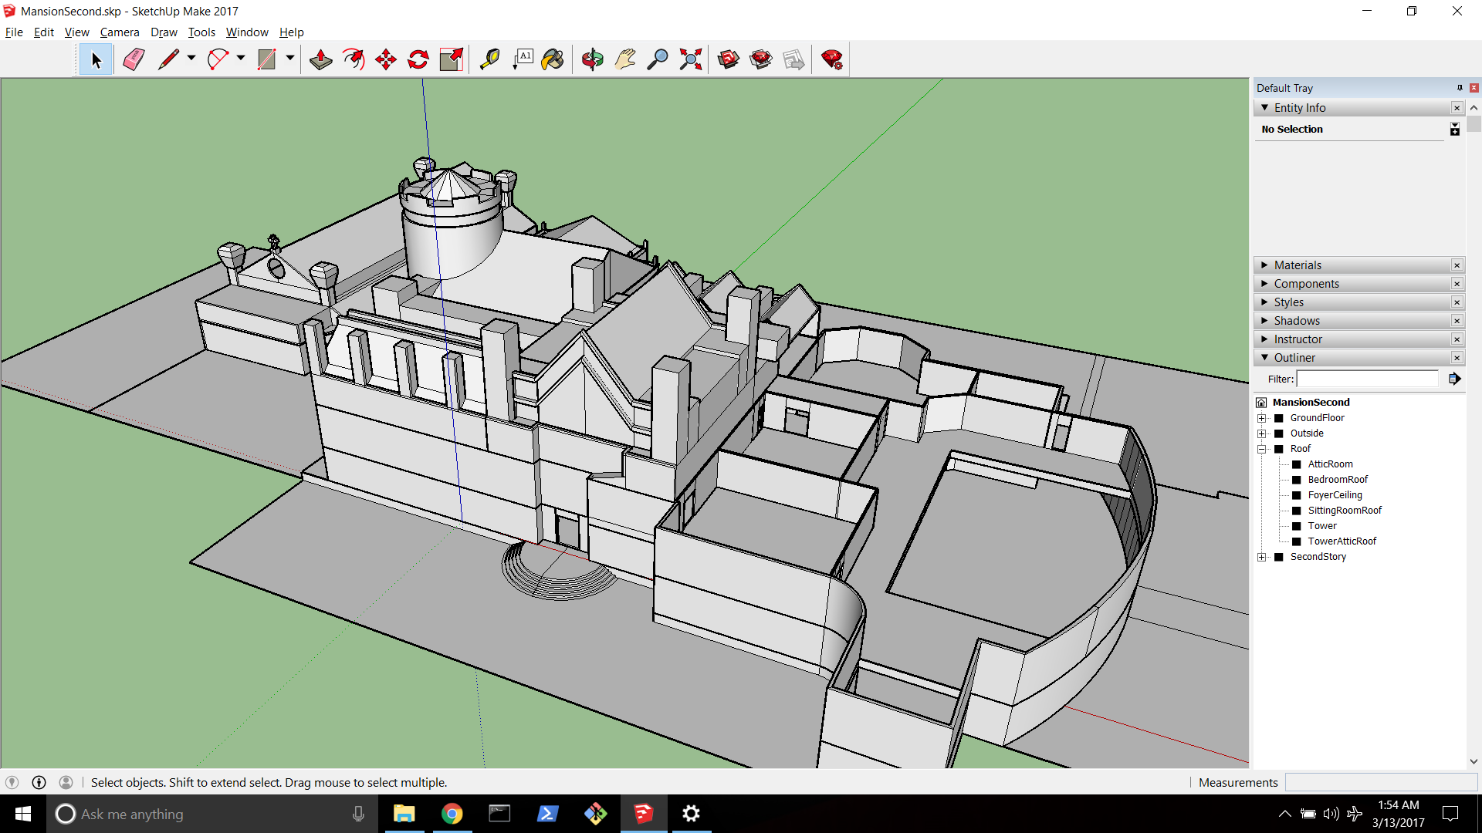

3-13-17 Started work on roof at noon

2:30 PM finished roof

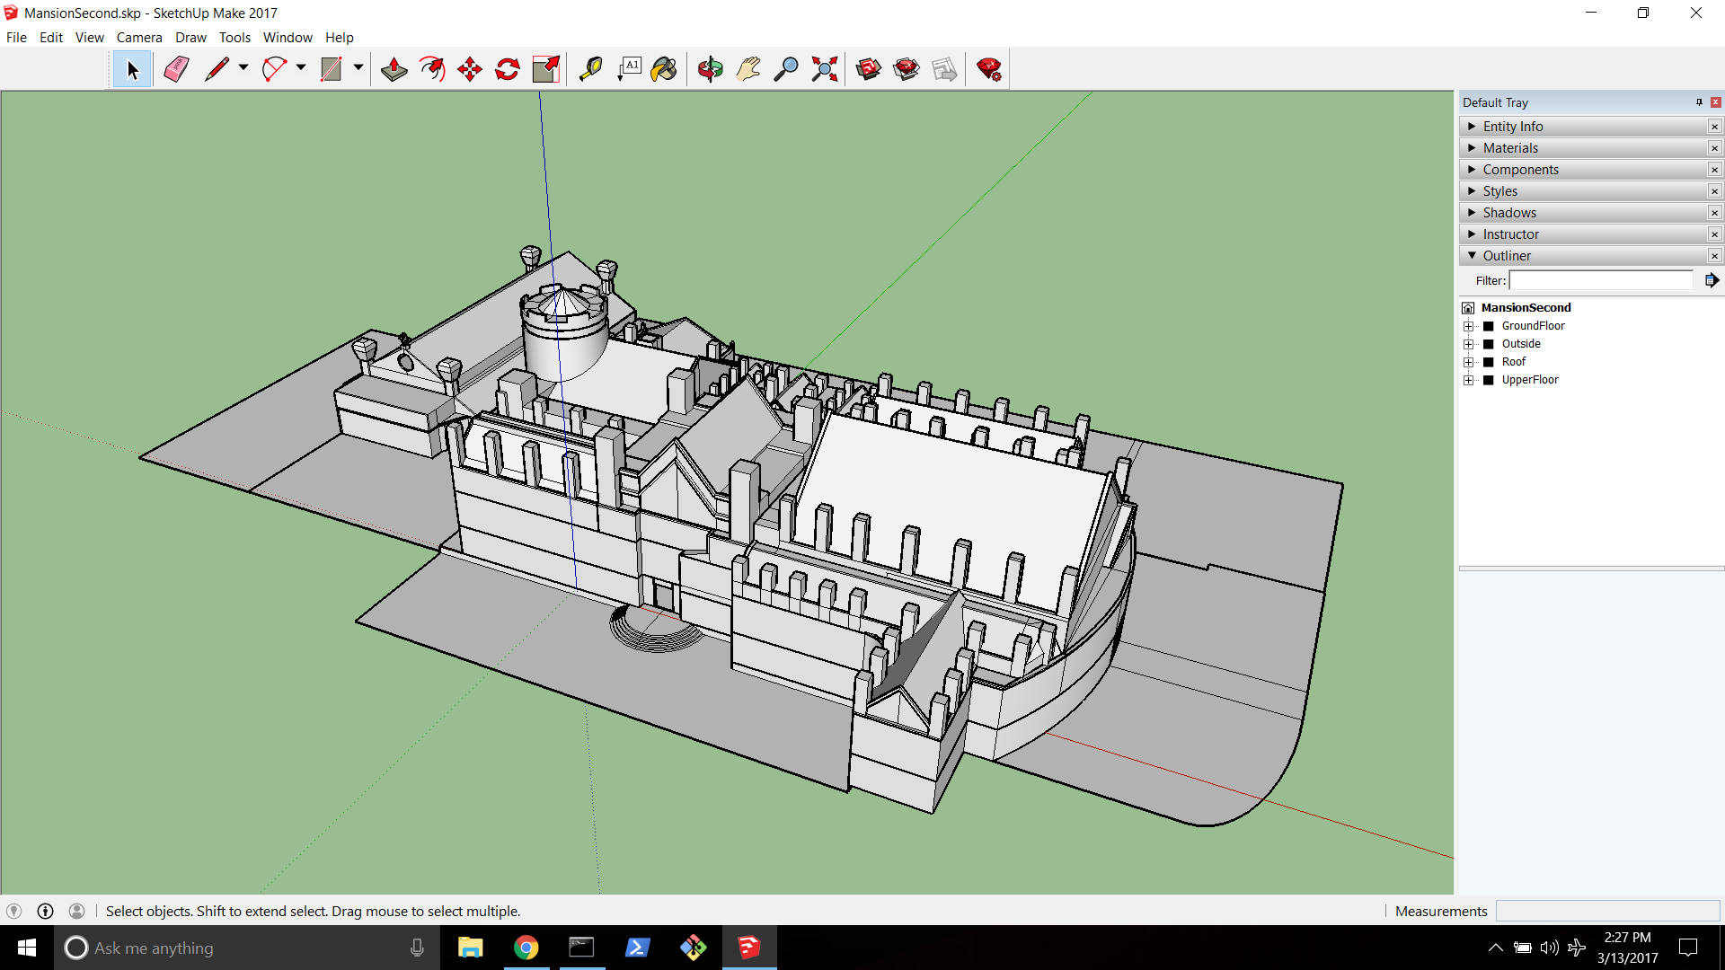

8:52 PM finished basement

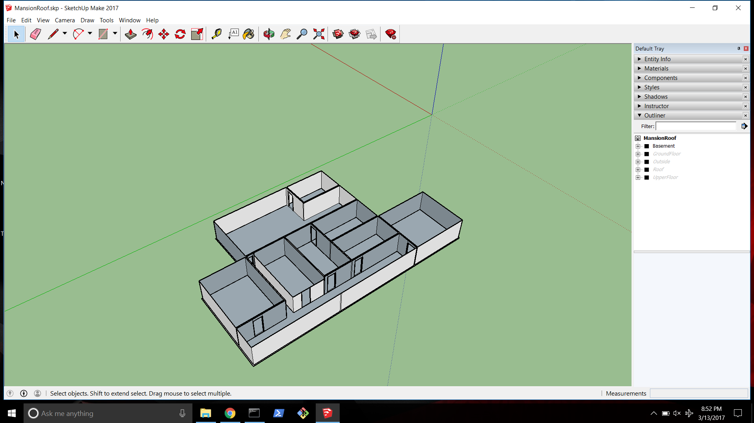

Picture of preliminary mansion

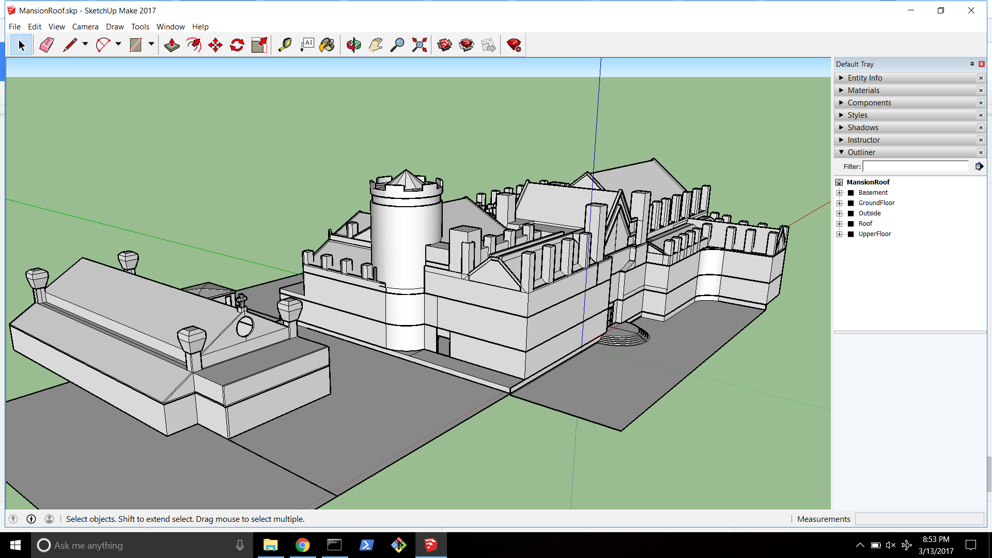

3-16-17

Started texturing house

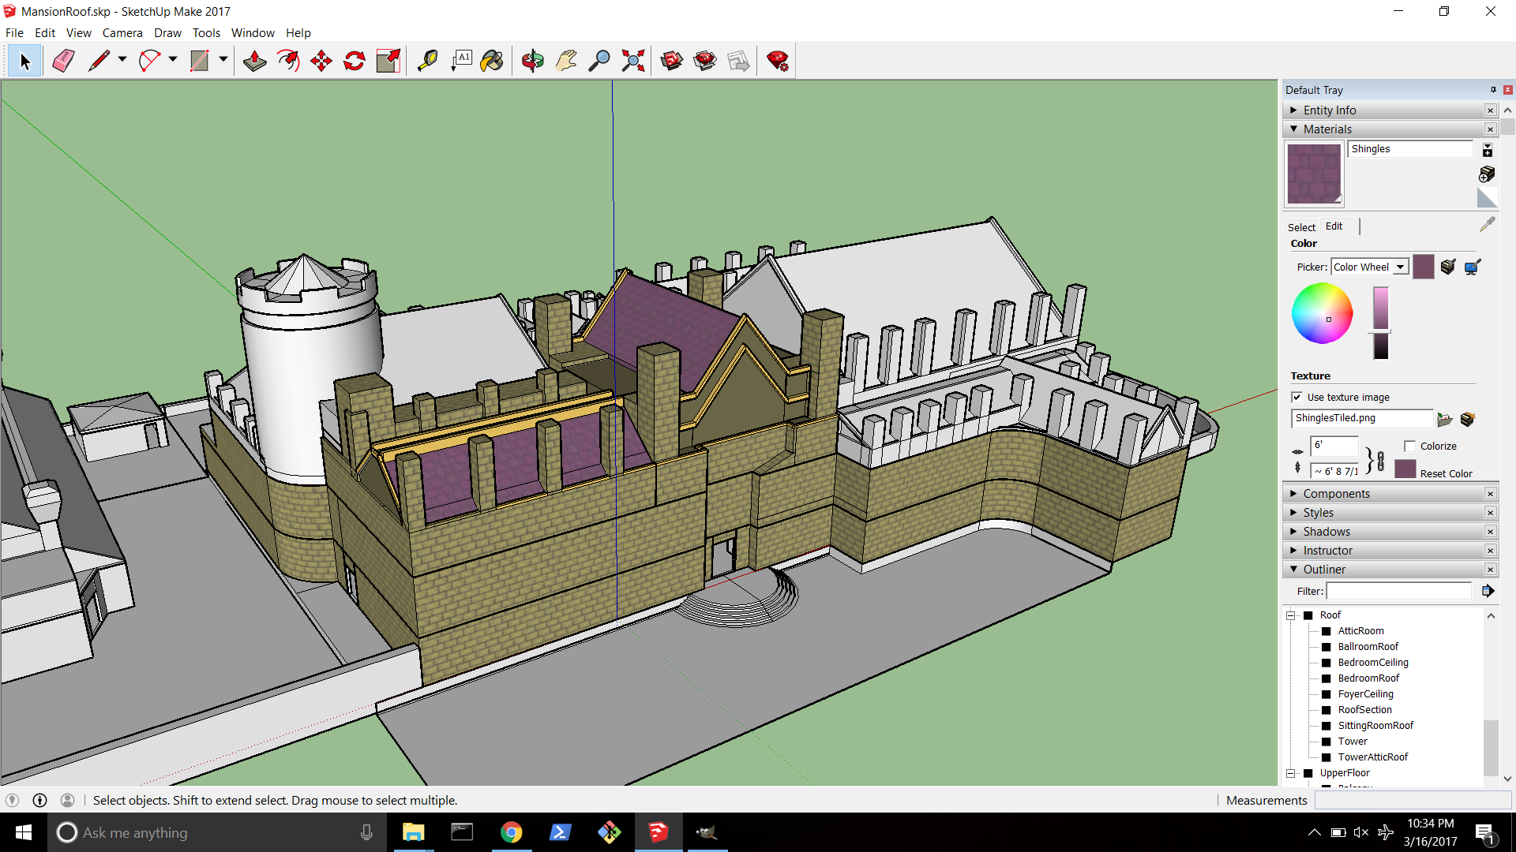

Fully textured outside of main house

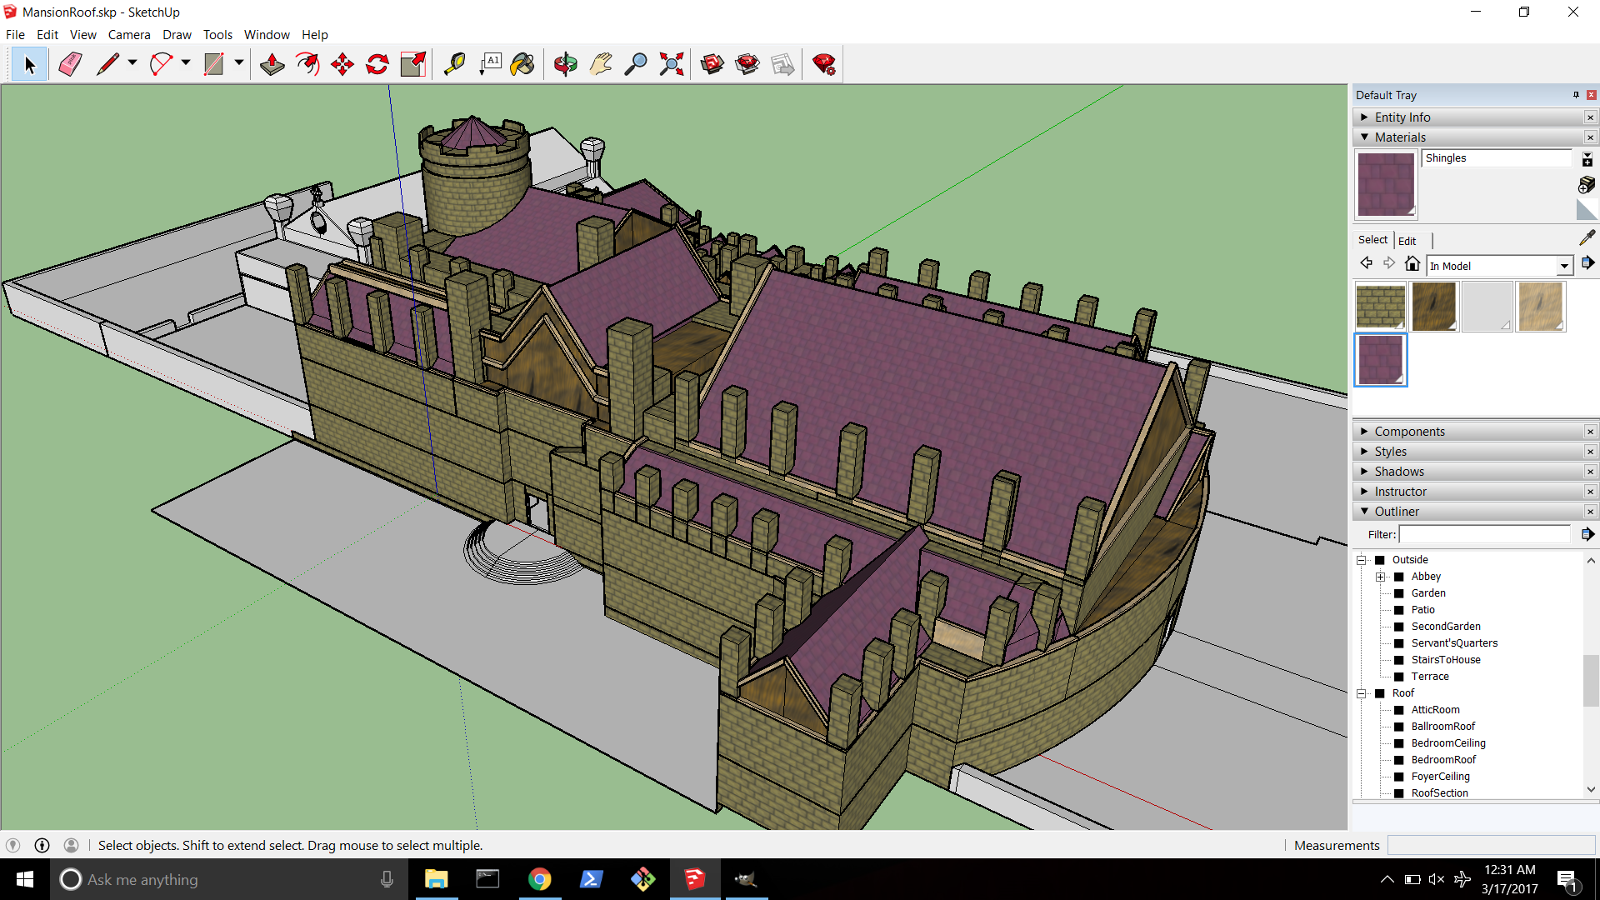

Pictures of entrance hall

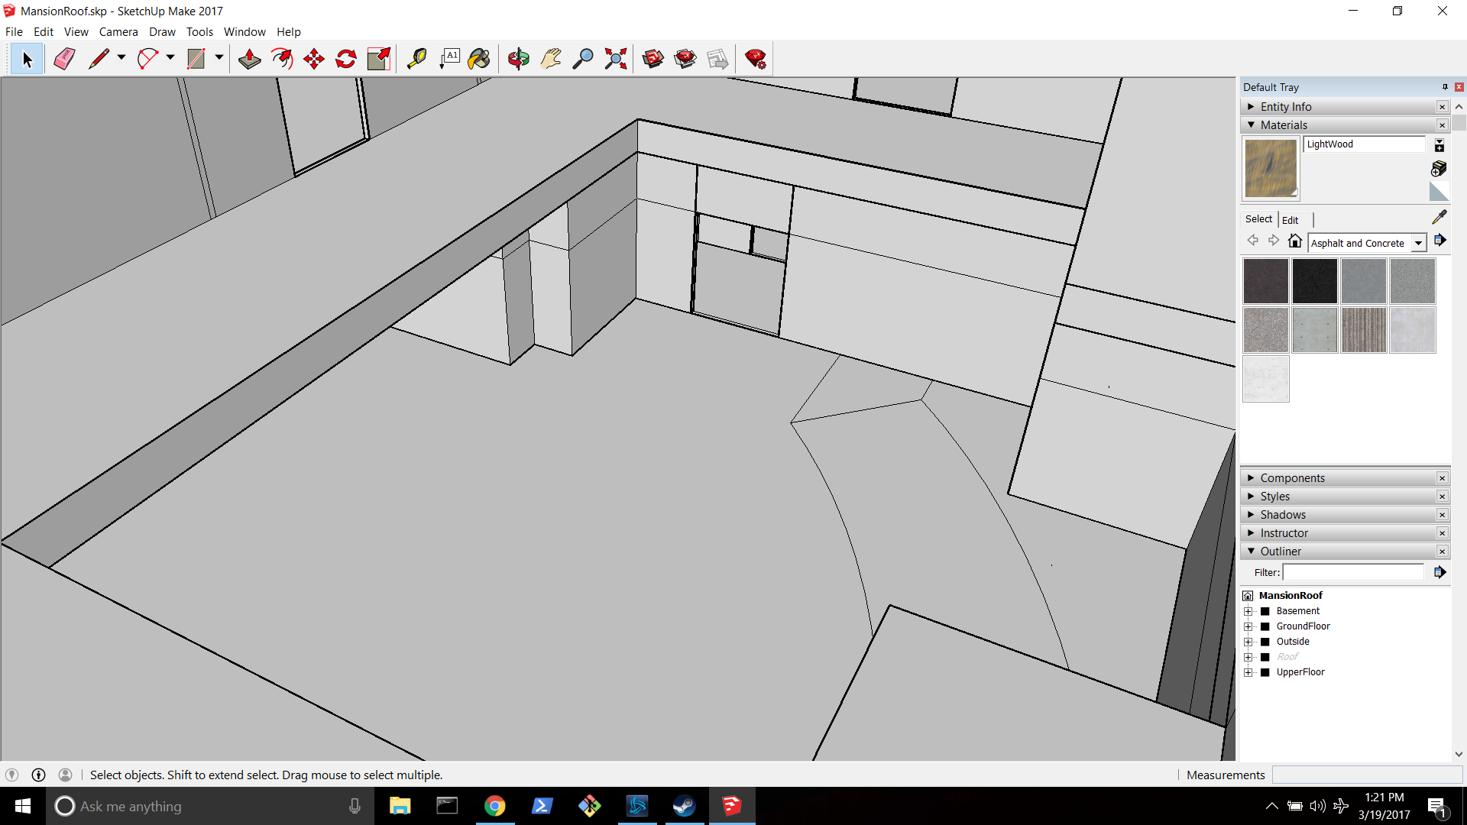

Picture from far side of room

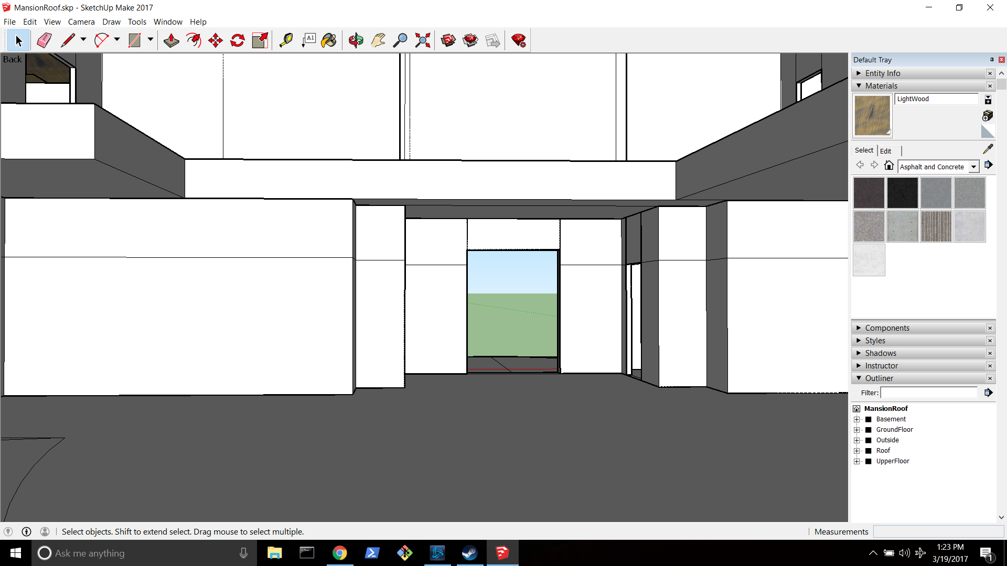

Sketch front room

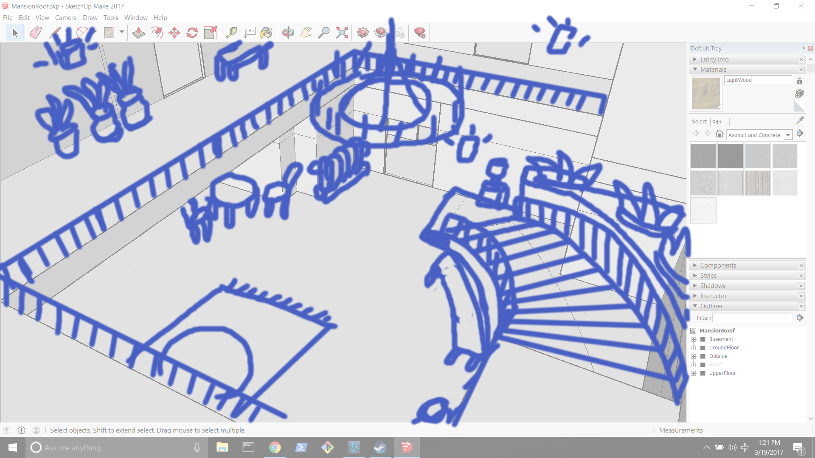

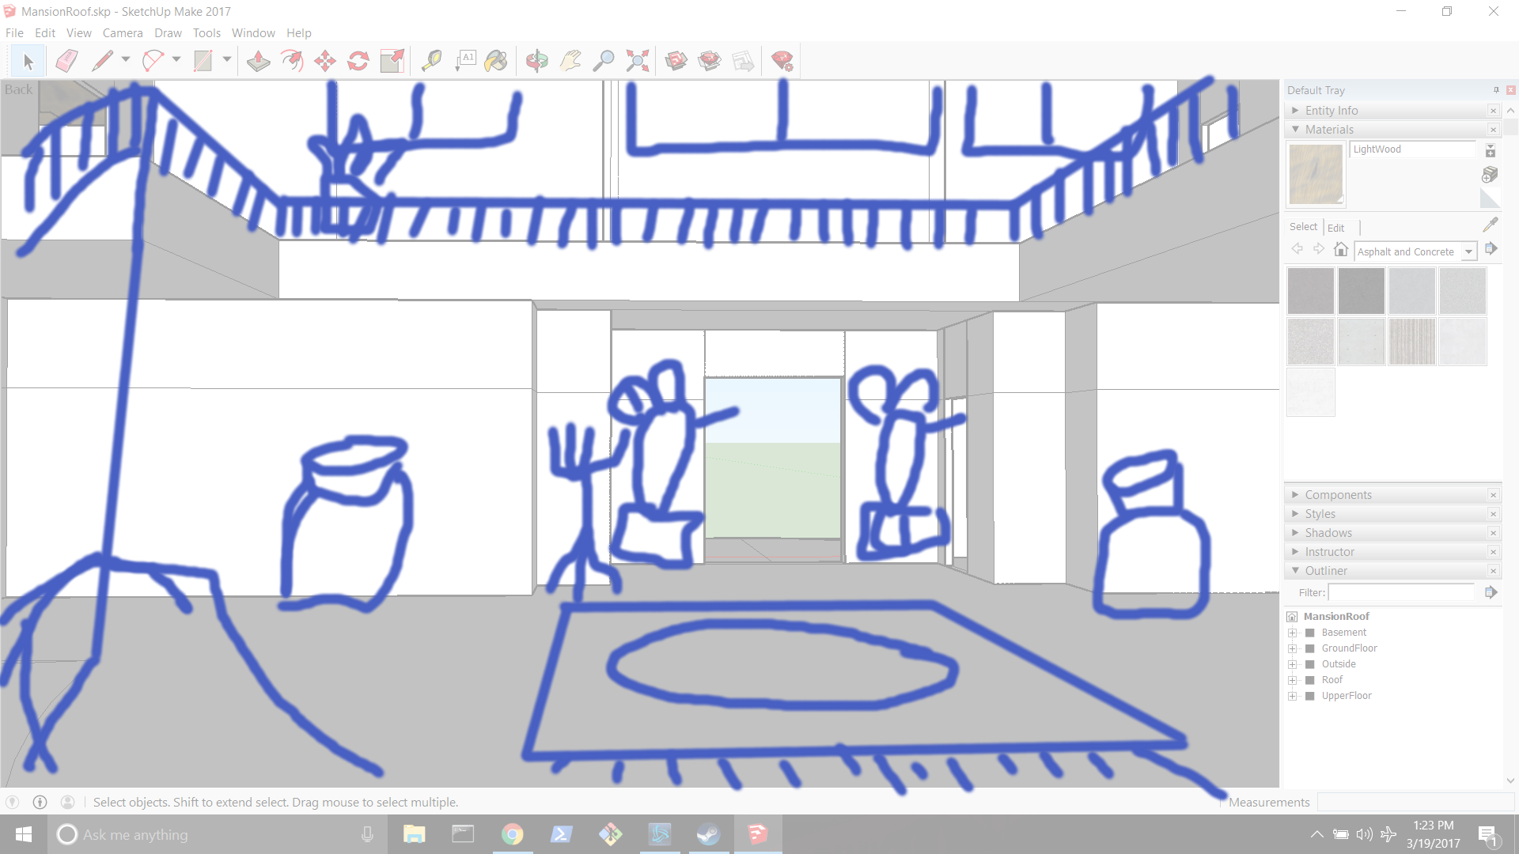

Plants/Vases (decorations)

Square table

Round table

Angled Table (or square if i’m lazy)

Stairs

Railings

Radiator

Chairs

Rug

Ledge

Lamp

Chandelier

Sculptures (pretty stuff) lots of these

Coat hanger thingy

windows

Pictures to go on walls and tables

Picture for designs

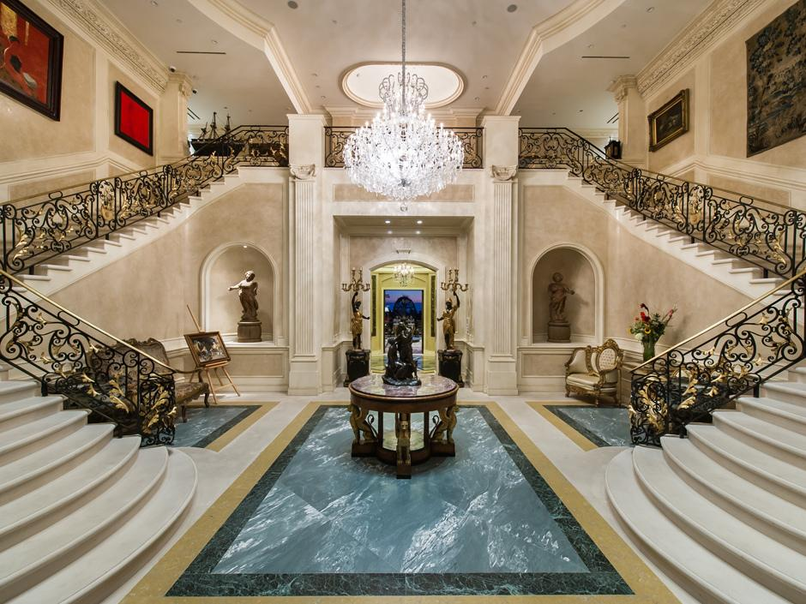

3-25-17

For ours use color theme of grey, black, brown and red.

More stone and wood theme less marble:

